**Linux Shell Script**

**Practice1:**

**Write a shell script file in the current shell, assign executable permission to this file, execute this file in the current process and also execute in a subprocess shell, and print its process ID, as verify the scope of the local and global variables that have been defined in the shell.**

写一个脚本文件，并赋予它可执行权限，然后分别在当前进程以及子进程中执行这个脚本程序。要求该脚本程序打印当前进程号，并验证已经在Shell中定义了的本地和全局变量的作用域范围。



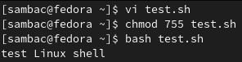

**Practice2:**

**Write one script file complete the following operations:**

**1. Create new two directories in your user's home directory: subdir1 subdir2**

**2. Copy the file /etc/passwd to subdir1, copy the file /etc/group to subdir2**

**3. Rename the directory subdir2 to subdir**

**4. Package and compress the directory subdir1 into xz format**

**5. Copy the packaged xz format file to the directory subdir**

**6. Decompress the compressed format file in the directory subdir**

**7. List all the files in the directory subdir**

在一个脚本文件中完成以下所有的操作（按照顺序）：

1. 在自己的用户主目录下新建两个子目录subdir1 subdir2

2. 将/etc/passwd文件拷贝到subdir1, 拷贝/etc/group到subdir2

3. 将subdir2重命名为subdir

4. 对subdir1进行打包并且压缩成xz格式

5. 将打包后的xz格式文件拷贝到subdir目录下

6. 解压subdir目录下的压缩格式文件

7. 查看subdir目录下所有的文件

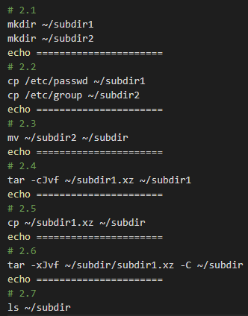

**1. Variables**

**Practice3:**

**<1> Define a variable VAR1, to save PATH environment variable content**

**<2> Define a variable VAR2, to save HOME environment variable content**

**<3> Exchange the content of VAR1 and the VAR2, and then output the values of these variables**

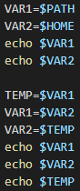

**2. input and output**

**Practice4:**

**Assigns the first value entered by the user to the variable var1, the** **second value entered by the user to var2, and the rest of the value is assigned to var3.**

**Exchange the content of var1 and the var2, and output the values of these three variables.**

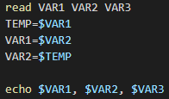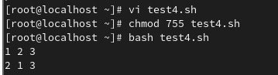

**Practice5:**

**Input an existing username and find its line number in the file /etc/passwd, and output the information of this user in the passwd file as the follows**

**Line number: 16**

**UserInfo is as follows: NAME: UID: GID**

通过输入一个（已经存在的）用户名来寻找用户在/etc/passwd中的行号，并输出这一行对应/etc/passwd文件中用户信息并按照以下格式输出打印

Line number: 16

UserInfo is as follows: NAME: UID: GID

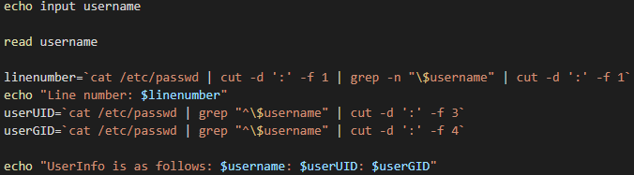

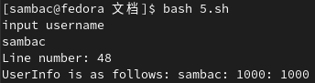

**3.数据的计算**

**Practice 6:**

**Enter two numbers from the keyboard and then output the calculation results of addition, subtraction, multiplication and division.**

（从键盘输入两个数，输出所有加减乘除的计算结果）

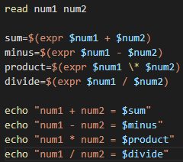

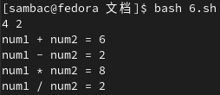

**4.判断的对象**

**Practice 7:**

**Enter a score and use a case statement to determine the grade of the score (solution key: score /10)**

**(80-100) A 8, 9, 10**

**(60-80) B 6, 7**

**(0-60) C 0, 1, 2 , 3, 4, 5**

**If the score is not [0-100], then prompt that the input is an illegal score.**

(输入一个成绩，用case语句判断成绩的等级 （解题思路:将成绩/10）

[80-100] A 8，9，10

[60-80 ) B 6，7

[0-60 ) C 0，1，2，3，4，5

如果成绩非法不是[0-100],则提示用户输入的成绩是非法的成绩)

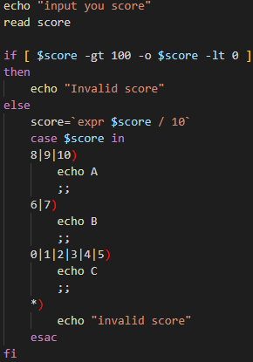

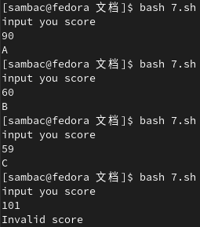

**(3) 循环**

**Practice7:**

**Calculate the result of 1 + 2 + ...... + 100.**

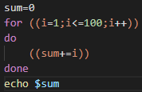



**Practice8:**

**Enter a path and determine whether the path is legal (whether it exists), and if so, output the number of normal files under the path.**

(输入一个路径，并判断该路径是否合法（是否存在该路径），如果合法，则输出该路径下的普通文件的个数。)

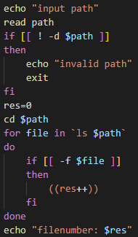

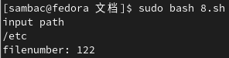

**三 shell 函数**

**Practice9:**

**1. Design a function to receive the username and find the user in /etc/passwd, return its line number (if it exists: return line number, if it does not exist: return 0). (Tip: If the line number is an empty string, the user is not found)**

**2. Design a function to receive the line number, and outputs the corresponding information in the file /etc/passwd. The information must be output as follows**

**The user info: NAME:UID:GID**

**3. Read the username repeatedly, and then call the designed functions, output the user's information, if the user does not exist, report to the users that the username does not exist in the system. If the input is "quit", then the program ends.**

**You are required to complete all the above functions and operations in one script file.**

**1.设计一个函数，通过传递的用户名来寻找用户在/etc/passwd中的行号(存在:返回行号，不存在:返回0)。 （提示：如果行号为空字符串，则表明未找到该用户）**

**2.设计一个函数，通过传递的行号，输出这一行对应/etc/passwd文件中用户信息如下**

**The user info: NAME:UID:GID**

**3.循环读取用户输入的用户名，然后分别调用设计的函数，输出用户的信息，如果用户不存在，则告诉输入者这个用户在系统中不存在，如果输入的是"quit",则结束。**

**注：以上函数和操作都要在同一个脚本文件中完成。**

